# Stored Procedure

1. Get the number of movies released in a year. Input year, output count of movies.

Stored Procedure:

DELIMITER %%

CREATE procedure CountOfMovies_InYear(IN release_year VARCHAR(25),OUT Number_of_movies INT)

BEGIN

DECLARE search_pattern VARCHAR(255);

SET search_pattern = CONCAT(release_year,”-%-%”);

Select count(*) into Number_of_movies from movie_metadata where release_date like search_pattern;

END

%%

Call CountOfMovies_InYear(1999, @number_of_movies);

Select @number_of_movies;

1. Get top N movies by average rating with a minimum number of ratings.

Stored Procedure 2:

DELIMITER $$

CREATE PROCEDURE GetTopRatedMovies(

IN `limit` INT,

IN min_ratings INT

)

BEGIN

SELECT m.title, AVG(r.rating) AS average_rating, COUNT(r.rating) AS rating_count

FROM movie_metadata m

INNER JOIN ratings r ON m.tmdb_id = r.movie_id

GROUP BY m.title

HAVING rating_count >= min_ratings

ORDER BY average_rating DESC

LIMIT `limit`;

END

$$

call GetTopRatedMovies(2,5);

Screenshot 2:

1. Top 5 Collaborations of Director and Actors based on count

DELIMITER //

CREATE PROCEDURE display_top_collaborations(IN director_name VARCHAR(255))

BEGIN

SELECT

casts.name AS 'Cast Name',

GROUP_CONCAT(title) AS 'Collaborated Movies',

COUNT(*) AS 'Total Number of Collaborations'

FROM

casts

JOIN

movie_casts ON casts.credit_id = movie_casts.credit_id

JOIN

movie_crews ON movie_casts.tmdb_id = movie_crews.tmdb_id

JOIN

crews ON crews.credit_id = movie_crews.credit_id

JOIN

movie_metadata ON movie_metadata.tmdb_id = movie_crews.tmdb_id

WHERE

crews.name = director_name

AND department = 'Directing'

GROUP BY casts.name

ORDER BY COUNT(*) DESC

LIMIT 10;

END //

DELIMITER ;

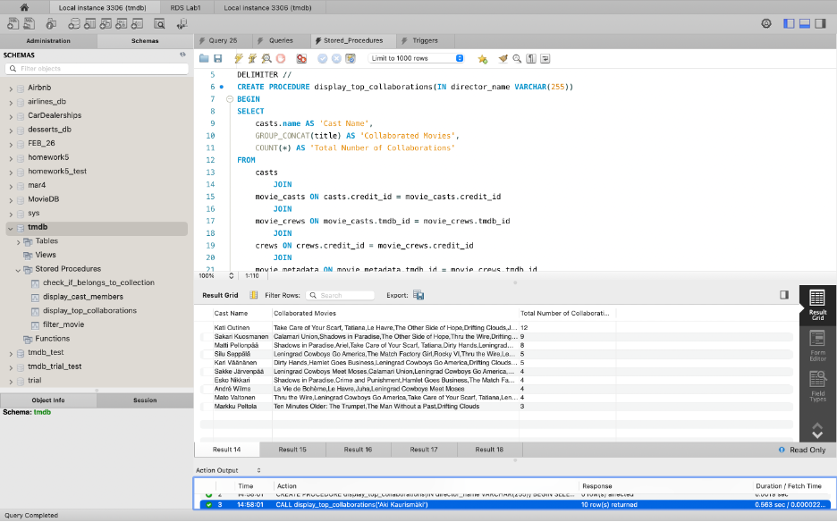

1. Filter the movies by genre, release year and language

DELIMITER //

CREATE PROCEDURE filter_movie(IN genre_name VARCHAR(255), IN language_code VARCHAR(255), IN release_year YEAR, IN lim int)

BEGIN

SELECT

original_title AS 'Movie Title', release_date AS 'Release Date', overview AS 'Synopsis', runtime AS 'Runtime'

FROM

movie_metadata

JOIN

movie_genres ON movie_genres.tmdb_id = movie_metadata.tmdb_id

JOIN

genres ON genres.genres_id = movie_genres.genres_id

WHERE

genres.name = genre_name

AND movie_metadata.original_language = language_code

AND YEAR(movie_metadata.release_date) = release_year

ORDER BY popularity desc

LIMIT lim;

END //

DELIMITER ;

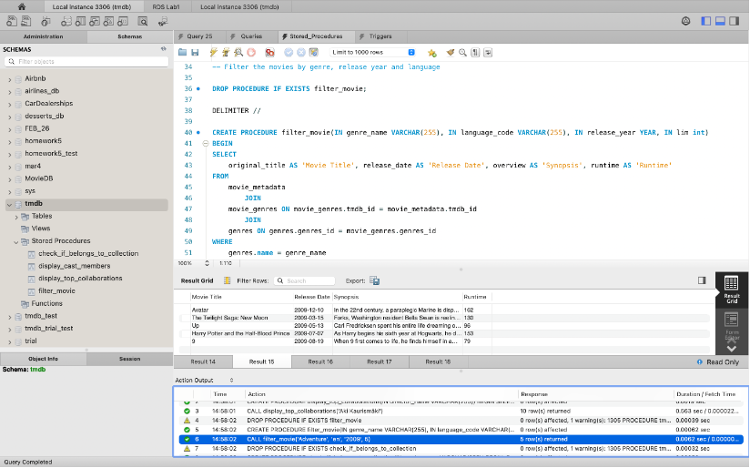

1. Check if a movie belongs to any collection

DELIMITER //

CREATE PROCEDURE check_if_belongs_to_collection(IN movie_name VARCHAR(255))

BEGIN

DECLARE collection_name VARCHAR(255);

SELECT belongs_to_collection.name INTO collection_name

FROM belongs_to_collection

INNER JOIN movie_belongs_to_collection ON belongs_to_collection.belongs_to_collection_id = movie_belongs_to_collection.belongs_to_collection_id

join movie_metadata on movie_belongs_to_collection.tmdb_id = movie_metadata.tmdb_id

WHERE movie_metadata.title = movie_name;

IF collection_name IS NOT NULL THEN

SELECT CONCAT(movie_name, ' belongs to collection: ', collection_name) AS result;

ELSE

SELECT CONCAT(movie_name, ' does not belong to any collection') AS result;

END IF;

END //

DELIMITER ;

